Transformation of Functions

Key Points:

- Even functions are symmetric about the y-axis, whereas odd functions are symmetric about the origin.

- Even functions satisfy the condition $f\left(x\right)=f\left(-x\right)$

- Odd functions satisfy the condition $f\left(x\right)=-f(-x)$

- A function can be odd, even, or neither.

- The summary of transformations written via equations is as follows:
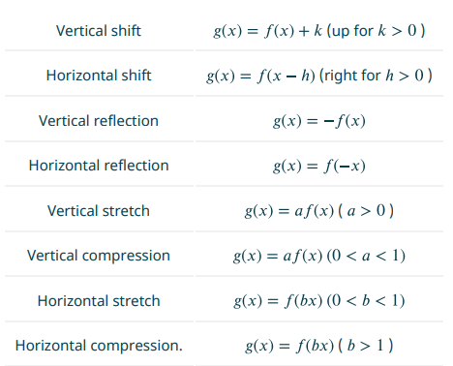
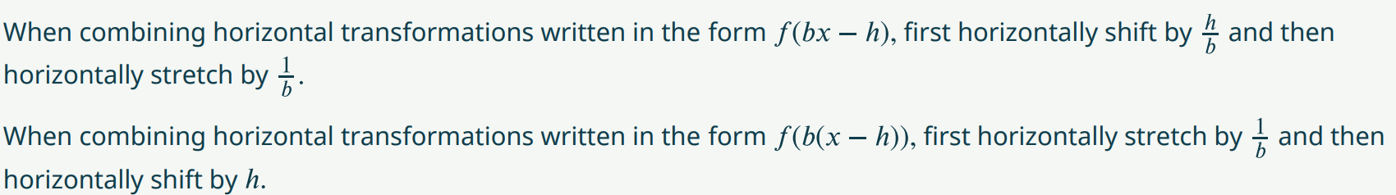

Tool Kit Functions:

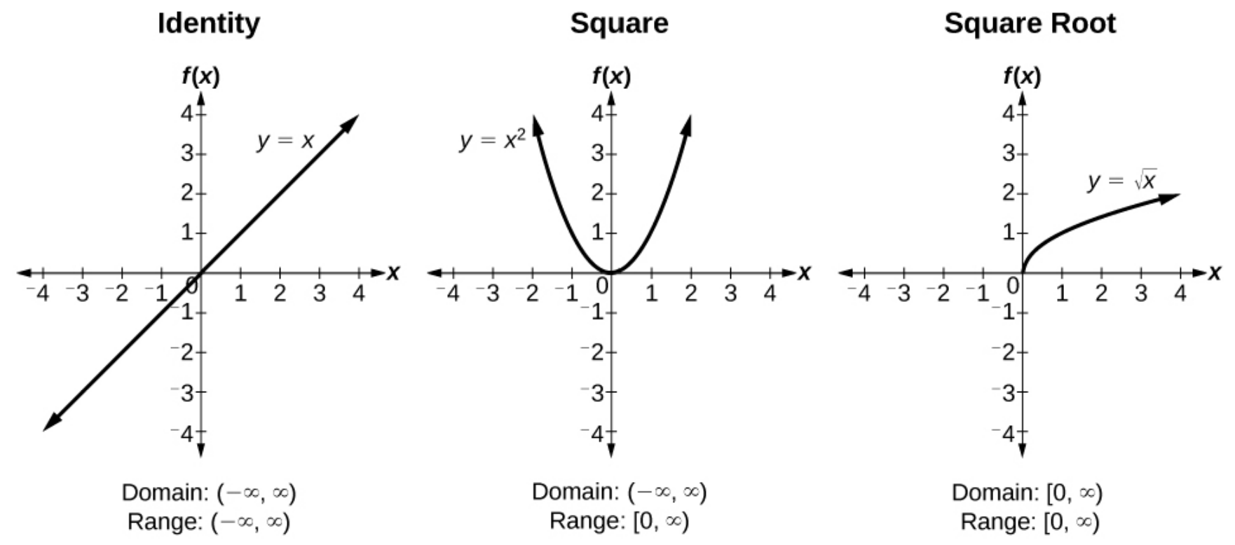
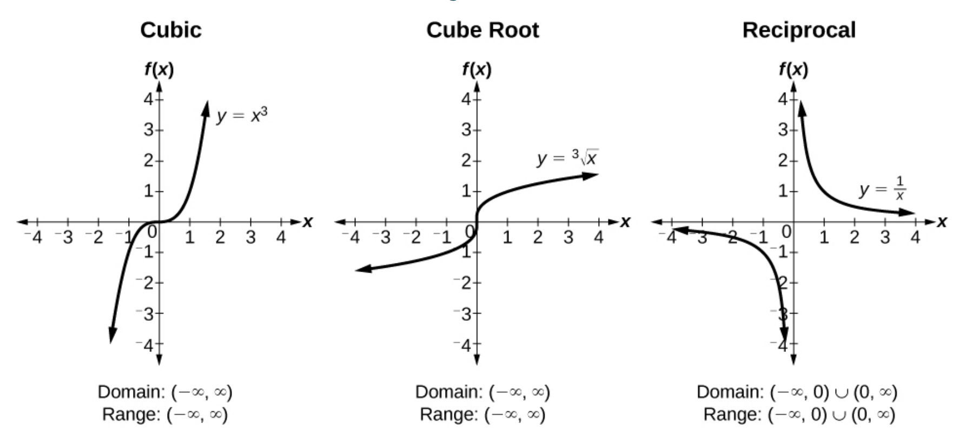
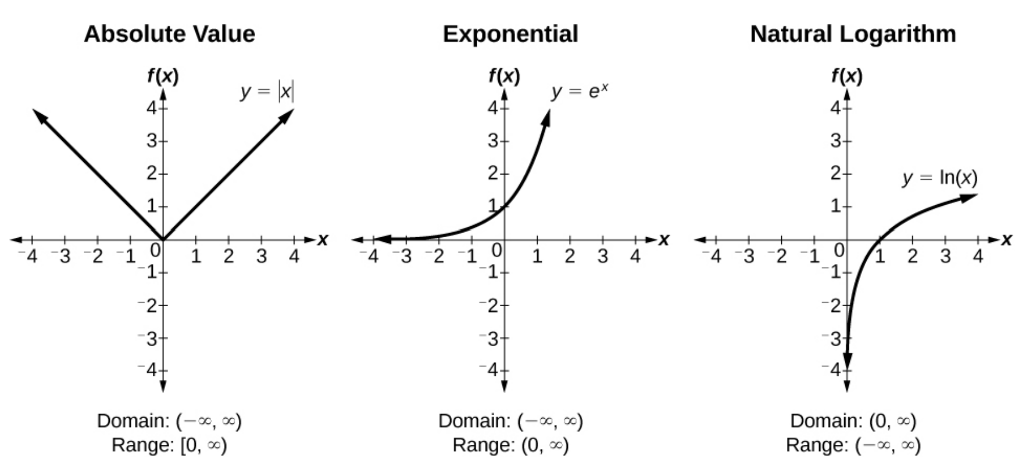

Transformation of Functions Videos
- Identifying Horizontal and Vertical Shifts: Examples 1-3
- Reflecting a Graph Horizontally and Vertically: Examples 4-6
- Determining whether a function is Even, Odd or Neither: Example 7
- Identifying Vertical Stretches and Compressions: Examples 8-9
- Identifying Horizontal Stretches and Compressions: Example 10
- Combining Transformations: Examples 11-12

Practice Exercises
Follow the directions for each exercise below:
- Sketch a graph of the given function: $f\left(x\right)={(x-3)}^{2}$

- Sketch a graph of the given function: $f\left(x\right)={(x+4)}^{3}$

- Sketch a graph of the given function: $f\left(x\right)=\sqrt{x}+5$

- Sketch a graph of the given function: $f\left(x\right)=-x^{3}$

- Sketch a graph of the given function: $f\left(x\right)=\sqrt[3]{-x}$

- Sketch a graph of the given function: $f\left(x\right)= 5\sqrt{-x}-4$

- Sketch a graph of the given function: $f\left(x\right)=$ $4[\left|x-2\right|-6]$

- Sketch a graph of the given function: $f\left(x\right)= -{\left(x+2\right)}^{2}-1$

For #9-10, Sketch the graph of the function g if the graph of the function f is shown in Figure.

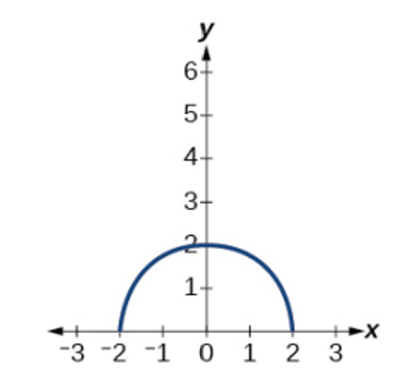

- $g\left(x\right)=f(x-1)$
- $g\left(x\right)=3f(x)$

- Write the equation for the standard function represented by the graph below:

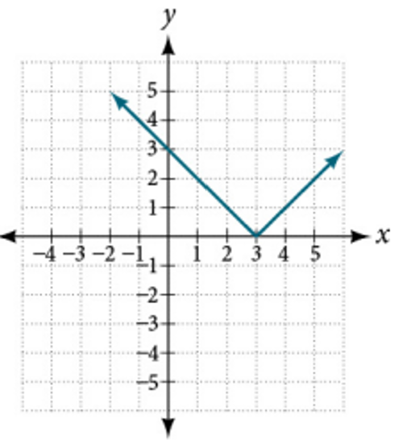

- Write the equation for the standard function represented by the graph below:
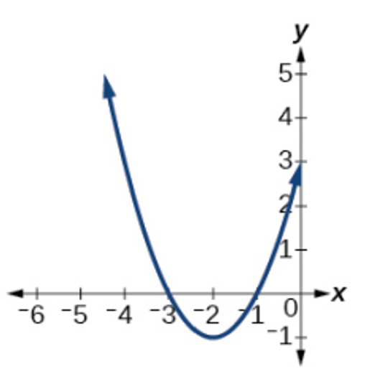

- Determine whether the given function is even, odd, or neither: $f\left(x\right)=3x^{4}$

- Determine whether the given function is even, odd, or neither: $f\left(x\right)=\sqrt{x}$

- Determine whether the given function is even, odd, or neither: $f\left(x\right)=\frac{1}{x}+3x$

- Analyze the graph below and determine whether the graphed function is even, odd, or neither:
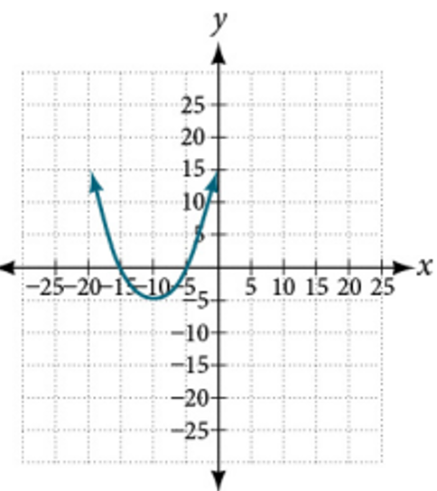

- Analyze the graph below and determine whether the graphed function is even, odd, or neither:
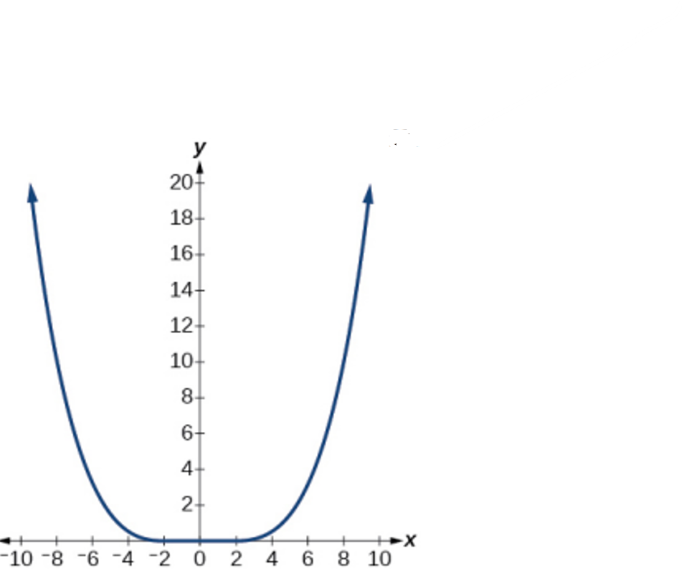

- Analyze the graph below and determine whether the graphed function is even, odd, or neither:

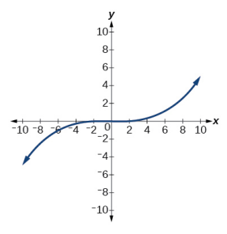

- Write an equation for the transformation of $f\left(x\right)=|x|$:

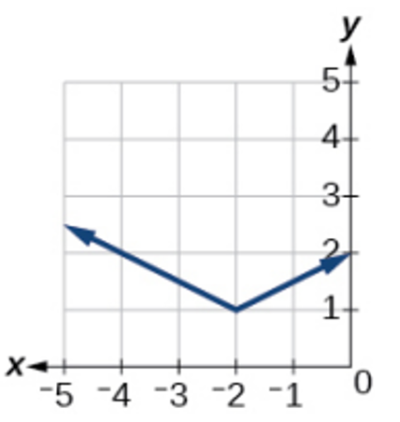

- Write an equation for the transformation of $f\left(x\right)=|x|$:
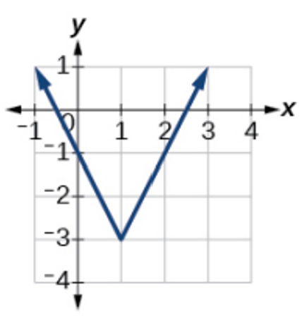

- Write an equation for the transformation of $f\left(x\right)=|x|$:

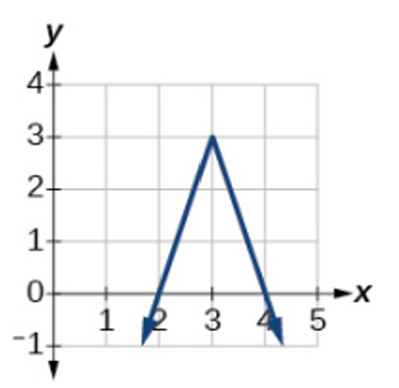

Answers:

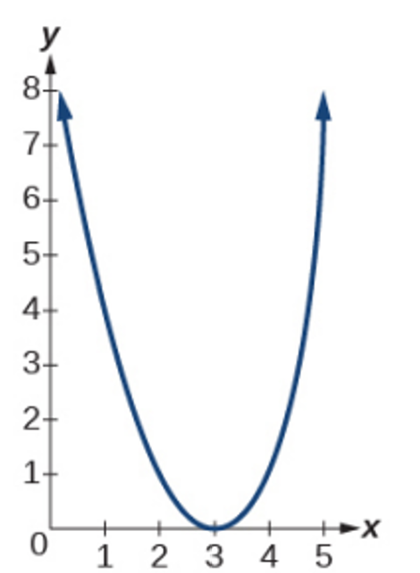

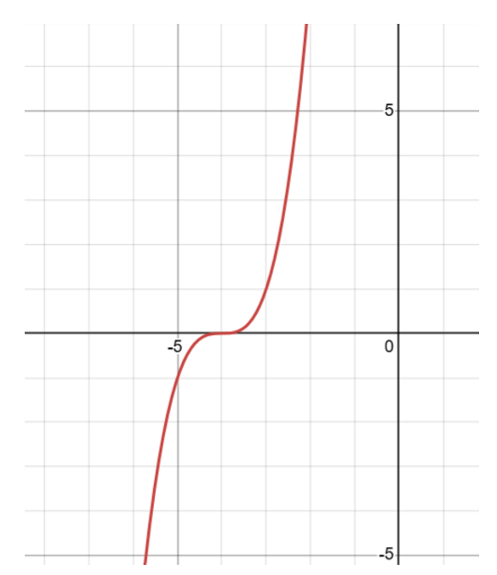

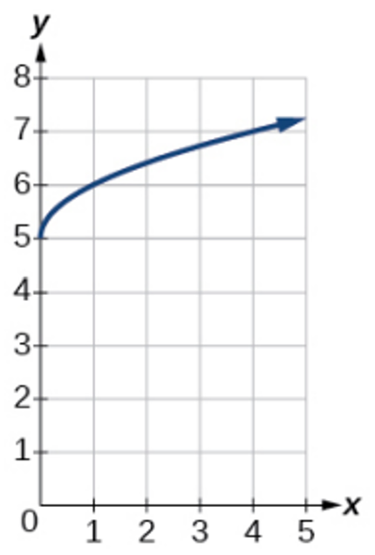

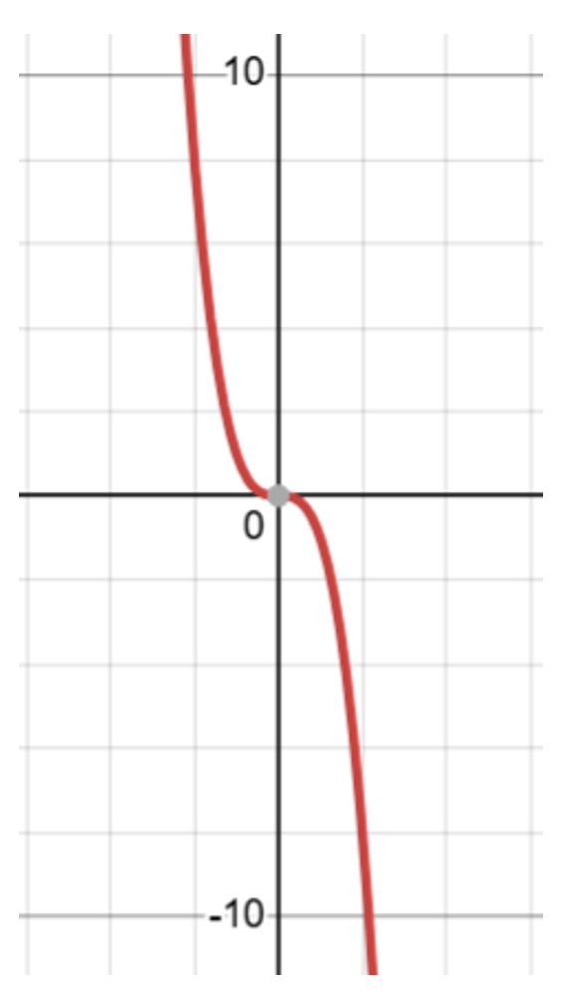

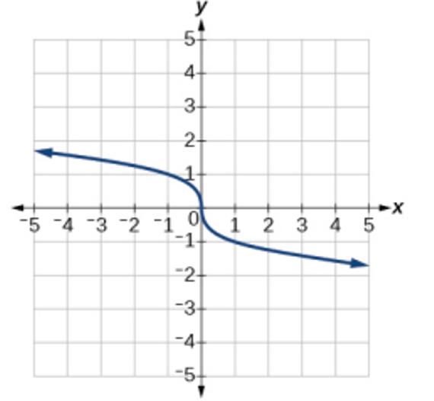

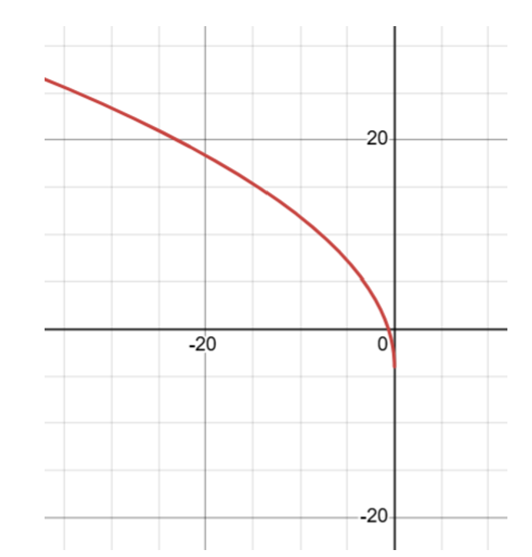

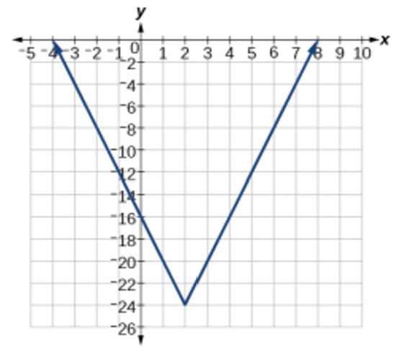

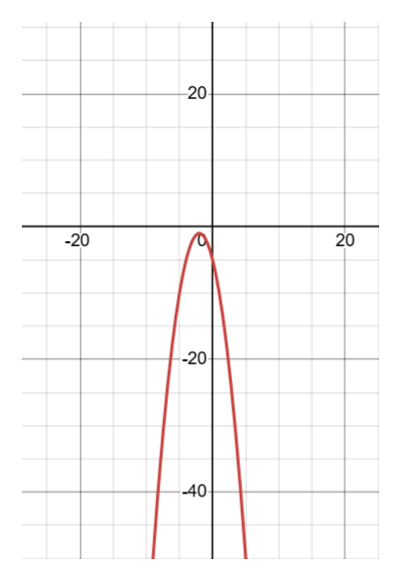

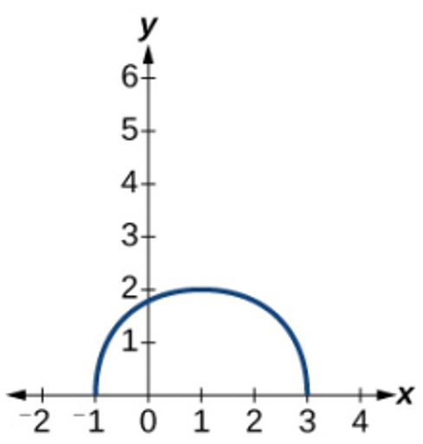

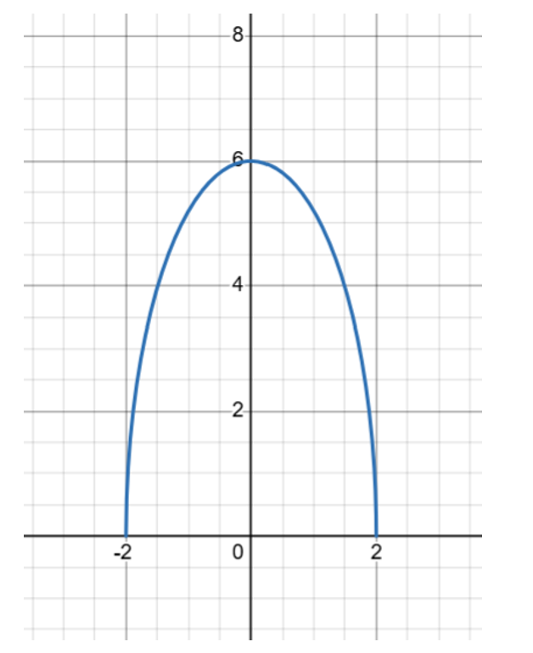

- $f\left(x\right)=|x-3|$

- $f\left(x\right)={(x+2)}^{2}-1$

- Even

- Neither

- Odd

- Neither

- Even

- Odd

- $f\left(x\right)=\frac{1}{2}\left|x+2\right|+1$

- $f\left(x\right)=2\left|x-1\right|-3$

- $f\left(x\right)=-3\left|x-3\right|+3$

